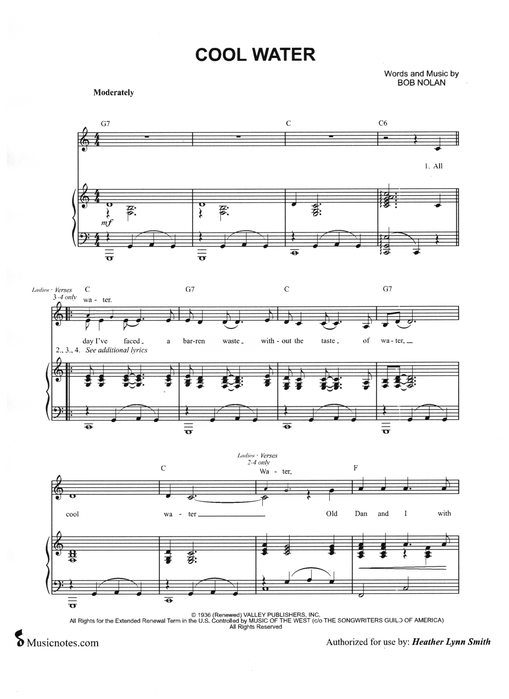
320

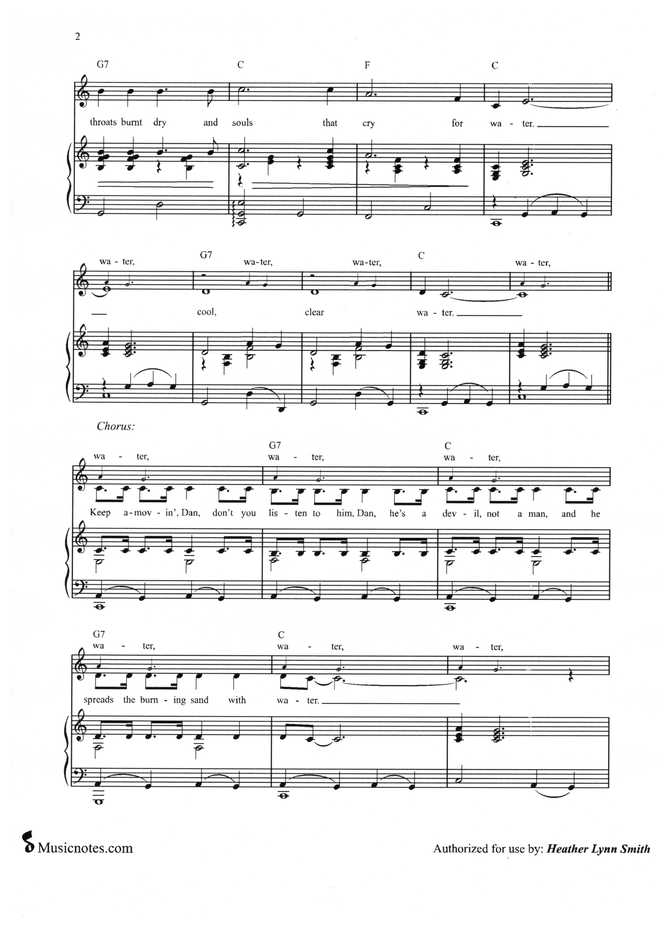
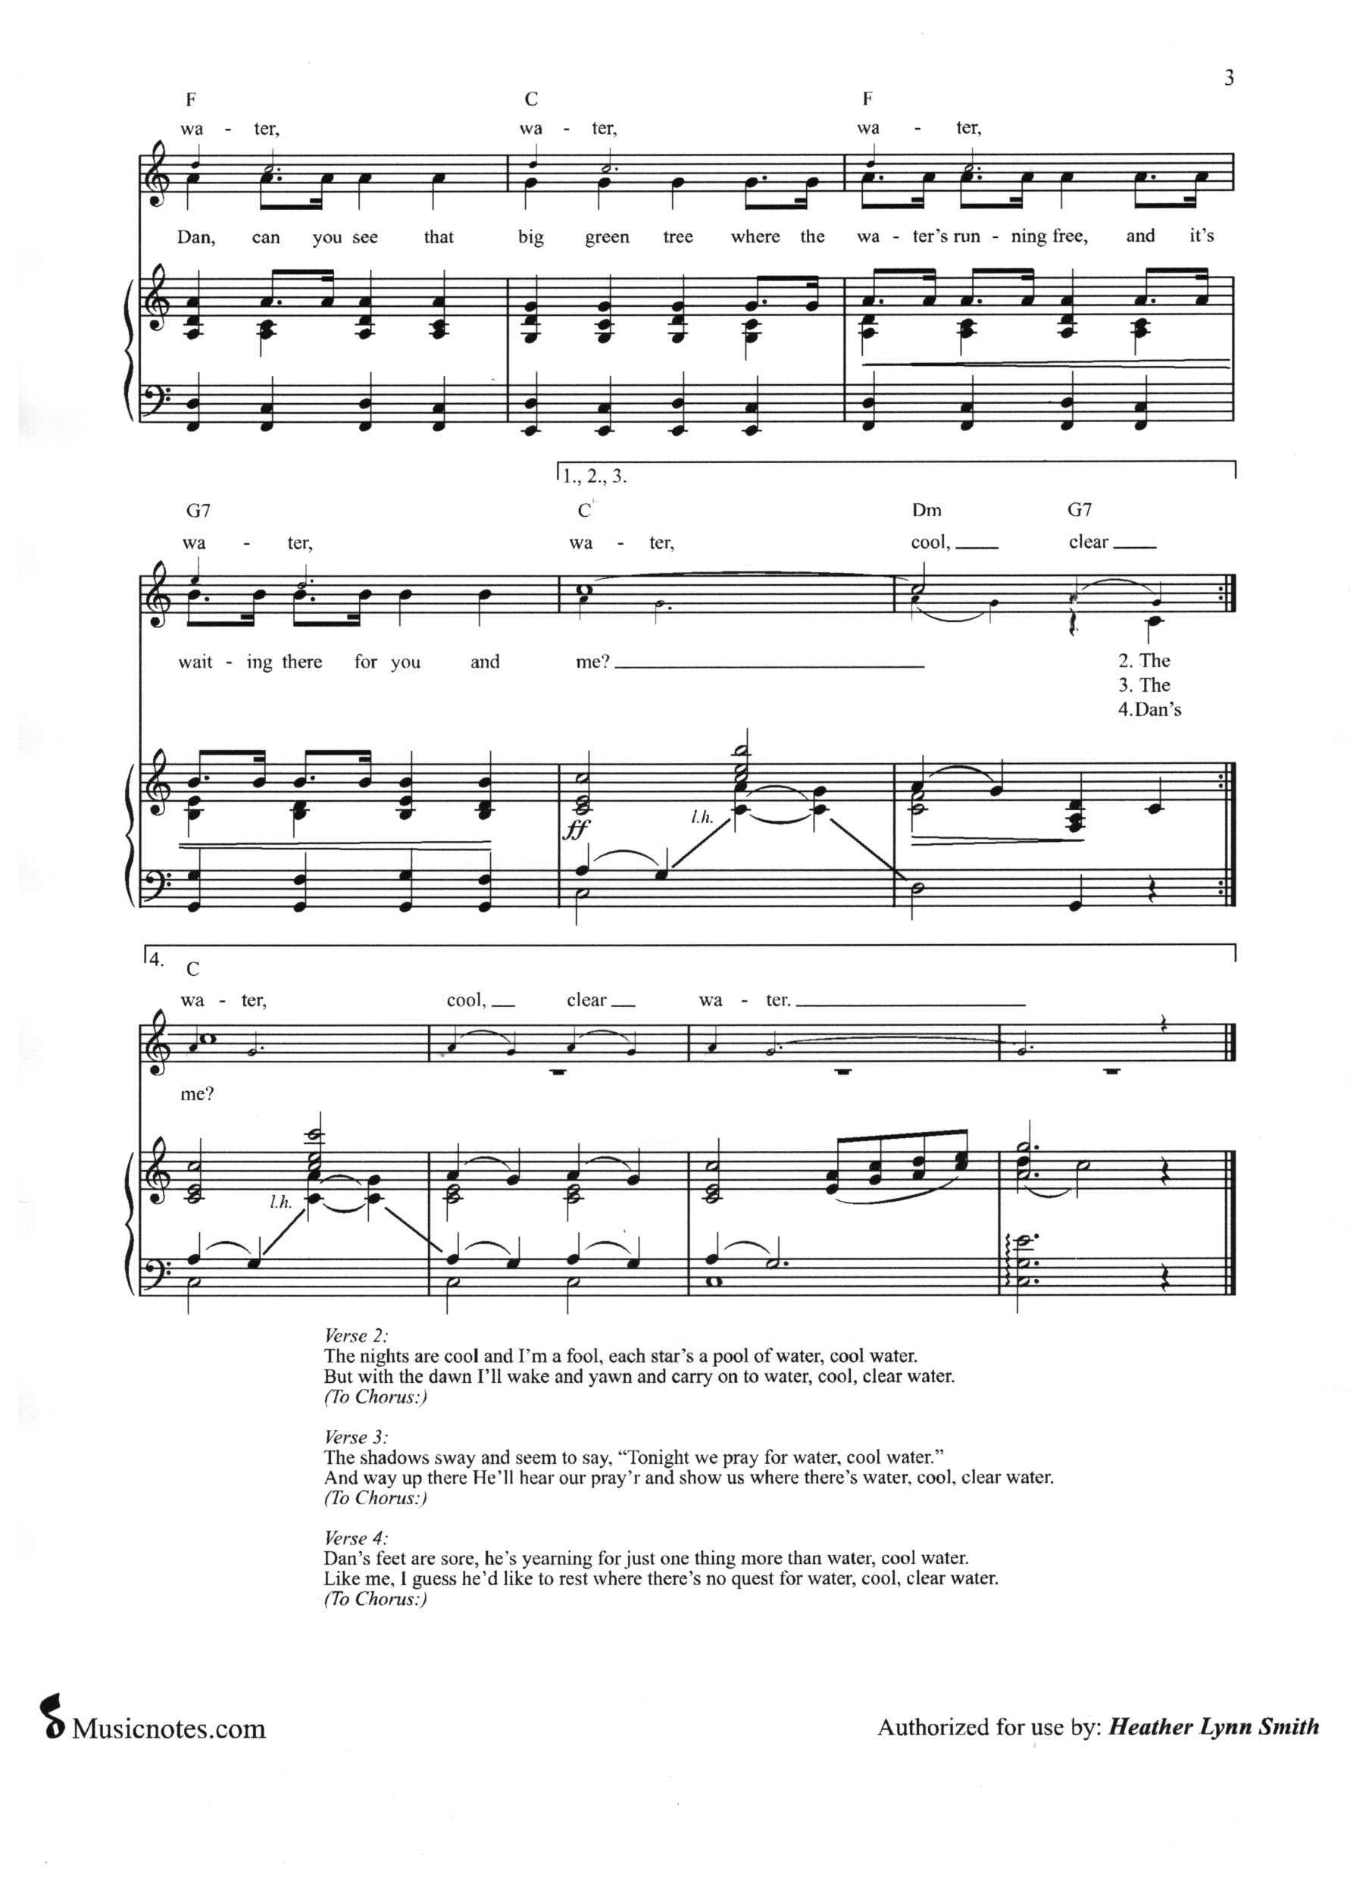
Cool Water 320
All day I’ve faced a barren waste without the taste of
water, cool – water –
Old Dan and I with throats burnt dry and souls that cry for water, cool – clear – water –
Keep a movin’ Dan, don’t you listen to him Dan, He’s a devil
not a man and he spreads the burning sand with water – –
Dan can you see that big green tree where the water’s running free and it’s waiting there for you and me?
(sopranos add “water” at each *)
The nights are cool and I’m a fool, each star’s a pool of
water, cool – water – *(water)
But with the dawn I’ll wake and yawn and ca–rry on– to
water –*– cool –*– clear –*– water – – –*–
*Keep a movin’ Dan, don’t you *listen to him Dan, He’s a *devil not a man and he *spreads the burning sand with *water – –*–
*Dan can you see that *big green tree where the *water’s running free and it’s *waiting there for you and *me? (cool, clear
The *shadows sway and seem to say “Tonight we pray for
water”, cool – water – *(water)
And way up there he’ll hear our pray’r and show– us where– there’s water –*– cool –*– clear –*– water – – –*–
*Chorus (cool, clear
Dan’s *feet are sore, he’s yearning for just one thing more than water, cool – water –*–
Like me I guess he’d like to rest where the–re’s no que–st for water –*– cool –*– clear –*– water – –*–
*Chorus (cool, clear, water)

